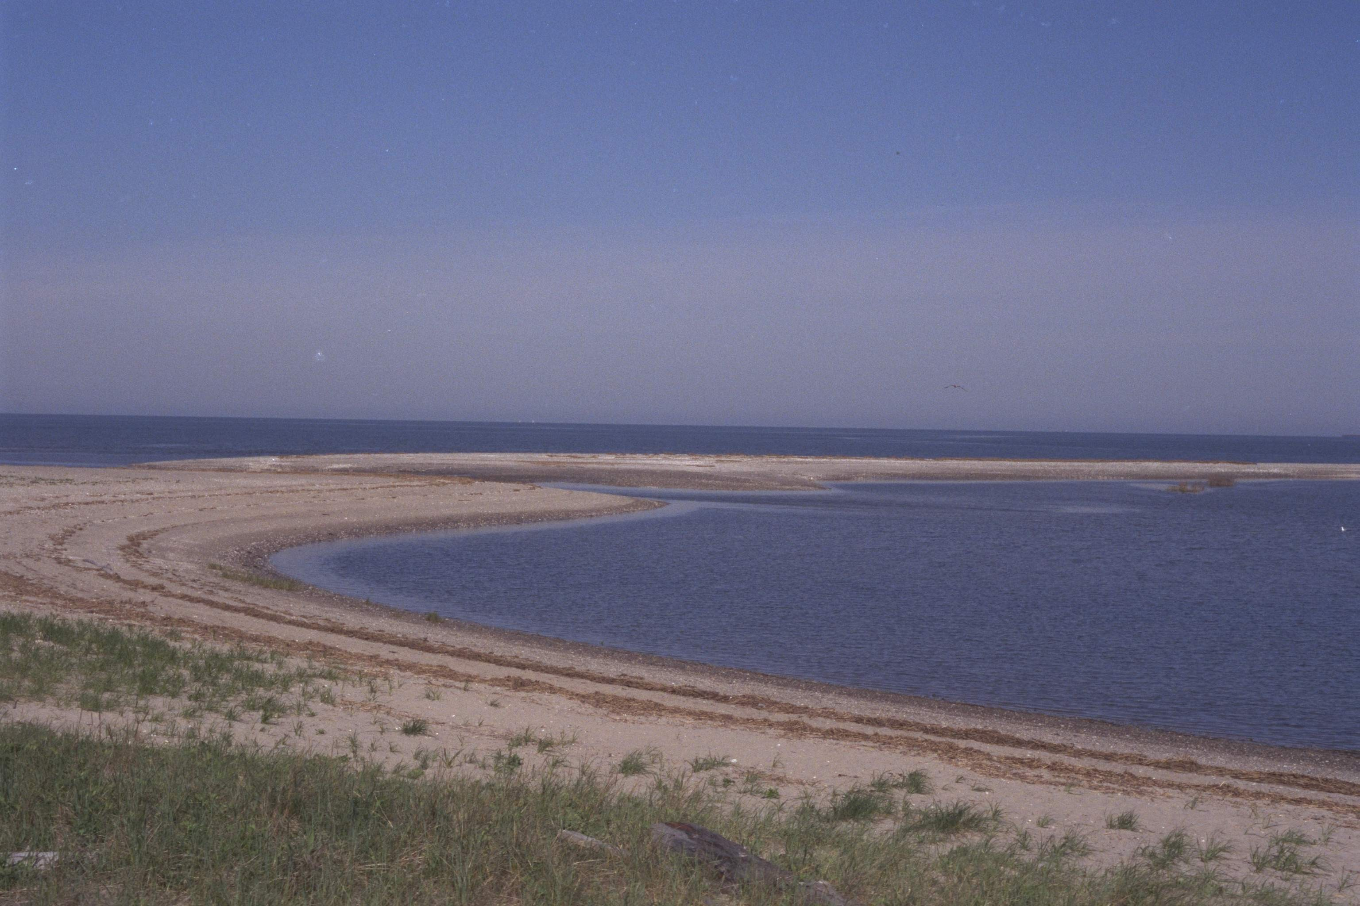

The Long Island Sound Stewardship Act of 2006:

Protecting where the land meets the sea

The Long Island Sound Stewardship Act of 2006 (LISSA) was signed into law October 16, 2006 to identify, protect, and enhance upland sites within the Long Island Sound ecosystem with significant ecological, educational, open space, public access, or recreational value through a bi-State network of sites best exemplifying these values.

The Long Island Sound Stewardship Act of 2006:

- Recognizes that Long Island Sound is a resource of national and regional significance with more than 10% of the United States population living within 50 miles of its shores and contributing an estimated $8.5 billion in 2006 dollars annually to the regional economy. The Act recognizes that less than 20% of the Sound’s shoreline is accessible to the public; and that approximately 1/3 of the Sound’s tidal marshes have been ditched or impounded, thereby greatly reducing their ecological value.

- Establishes a Long Island Sound Stewardship Initiative (LISSI), to identify, protect, and enhance sites within the Long Island Sound ecosystem.

- Establishes a LIS Stewardship boundary that encompasses the immediate coastal upland areas in the states of Connecticut and New York, as well as the Peconic Bay Estuary.

- Authorizes up to $25 million annually for each of the Fiscal Years 2007 to 2011 to help fund restoration and protection efforts. Requires at least a 40% local match for eligible projects.
Note: Congress has not appropriated any funding for LISSA as yet.

- Creates a Long Island Sound Stewardship Advisory Committee and lays out a process to identify stewardship sites based on their open space, recreational, and ecological significance. Public access is a key goal of the Initiative.

- Provides consistent criteria for selecting both recreational and ecological sites.

- Protects private property rights, and creates neither liability associated with, nor the requirement for, public access. No property owner can be required to participate in the Initiative unless they choose to do so voluntarily. Land or interest in land may be purchased only from willing sellers.

To achieve these goals, the Long Island Sound Stewardship Act of 2006:

(1) Establishes a Long Island Sound Stewardship Initiative Advisory Committee under the leadership of the U.S. EPA Administrator.

Committee Membership may include:

- Federal, state and local government and tribal interests
- Non governmental organizations
- Academic interests
- Private interests including landowners, agriculture, and business
- Recreational and fishing interests

Committee Responsibilities:

- Select and publicize a list of Long Island Sound Stewardship sites that are natural resource-based recreation areas or exemplary natural areas with ecological value, and that best promote the purposes of the Act.

- Evaluate grant applications to support the protection of land at stewardship sites by fee acquisition, land conservation agreements, site planning, plan implementation, land and habitat management, public access improvements, site monitoring, and other activities designed to enhance and preserve natural resource-based recreation and ecological function of upland areas.

- Recommend qualified grant applicants to the Administrator for funding, ensuring an equitable distribution of funds between the States to: help purchase property within a stewardship site; purchase relevant property rights to a stewardship site; or enter into any other legal arrangement that ensures the values of a stewardship site are sustained, including entering into an arrangement with a land manager or property owner to develop or implement a management plan that is necessary for the conservation of natural resources.

- Publish an annual report detailing the findings and conclusions of the Advisory Committee, a description of all sites recommended for designation as stewardship sites, recommendations for legislation and advisory actions, and recommendations for the awarding of grants.

- Requires the Administrator to publish a report every other year that:

- Assesses the role of the Act in protecting Long Island Sound
- Establishes, in coordination with the Advisory Committee, guidelines, criteria, schedules and due dates for evaluating information to designate stewardship sites
- Includes information about any grants that are available for the purchase of land or property rights to protect stewardship sites
- Accounts for funds received and expended during the previous fiscal year
- Is updated at least every other year, or more frequently, to reflect information on funding and any new stewardship sites
- Is available to the public on the Internet and in hard copy form

For additional information on the Long Island Sound Stewardship Initiative, contact Sandy Breslin, Director of Governmental Affairs at Audubon Connecticut at (203) 264-5098 x 307 or at sbreslin@audubon.org. Also, visit the EPA Long Island Sound Study’s website at: http://www.longislandsoundstudy.net/stewardship/index.htm.

This fact sheet was developed with the generous support of a grant from the National Fish and Wildlife Foundation’s Long Island Sound Futures Fund. The views and conclusions contained in this document are those of the authors and should not be interpreted as representing the opinions or policies of the U.S. Government or the National Fish and Wildlife Foundation. Mention of trade names or commercial products does not constitute their endorsement by the U.S. Fish and Wildlife Government or the National Fish and Wildlife Foundation.



